**EXP 5 HTTP GET and POST methods**

**AIM:**

To demonstrate the difference between HTTP GET and POST methods using a Java Servlet by creating a form that sends data using both methods.

**ALGORITHM:**

1. **Load Forms**
   * Display GET and POST forms with fields (Name, DOB, College)
2. **Capture Submission**
   * Prevent default form submission
   * Collect input values
3. **Simulate Methods**
   * **GET**: Generate a URL with query parameters
   * **POST**: Process data without URL exposure
4. **Display Results**
   * Show submitted data in "POSTY" section
   * For GET: Display simulated URL
   * For POST: Hide URL parameters
5. **Update UI**
   * Highlight method used (GET/POST)
   * Scroll to results smoothly

**PROGRAM:**

<!DOCTYPE html>

<html lang="en">

<head>

<meta charset="UTF-8">

<meta name="viewport" content="width=device-width, initial-scale=1.0">

<title>GET vs POST Demo</title>

<style>

body {

font-family: Arial, sans-serif;

max-width: 800px;

margin: 0 auto;

padding: 20px;

background-color: #f5f5f5;

}

.container {

display: flex;

gap: 30px;

}

.form-section, .result-section {

flex: 1;

background: white;

padding: 20px;

border-radius: 8px;

box-shadow: 0 2px 5px rgba(0,0,0,0.1);

}

h2 {

color: #333;

border-bottom: 2px solid #eee;

padding-bottom: 10px;

}

.form-group {

margin-bottom: 15px;

}

label {

display: block;

margin-bottom: 5px;

font-weight: bold;

}

input[type="text"],

input[type="date"] {

width: 100%;

padding: 8px;

border: 1px solid #ddd;

border-radius: 4px;

}

button {

background-color: #4CAF50;

color: white;

padding: 10px 15px;

border: none;

border-radius: 4px;

cursor: pointer;

font-size: 16px;

}

button:hover {

background-color: #45a049;

}

.result {

margin-top: 15px;

padding: 10px;

background-color: #f9f9f9;

border-radius: 4px;

}

</style>

</head>

<body>

<h1>GET vs POST Method Demonstration</h1>

<div class="container">

<div class="form-section">

<h2>GET (Form Submission)</h2>

<form id="getForm" action="FormServlet" method="GET">

<div class="form-group">

<label for="name">Name:</label>

<input type="text" id="name" name="name" required>

</div>

<div class="form-group">

<label for="dob">Date of Birth:</label>

<input type="date" id="dob" name="dob" required>

</div>

<div class="form-group">

<label for="college">College Name:</label>

<input type="text" id="college" name="college" required>

</div>

<button type="submit">Submit via GET</button>

</form>

</div>

<div class="form-section">

<h2>POST (Form Submission)</h2>

<form id="postForm" action="FormServlet" method="POST">

<div class="form-group">

<label for="name2">Name:</label>

<input type="text" id="name2" name="name" required>

</div>

<div class="form-group">

<label for="dob2">Date of Birth:</label>

<input type="date" id="dob2" name="dob" required>

</div>

<div class="form-group">

<label for="college2">College Name:</label>

<input type="text" id="college2" name="college" required>

</div>

<button type="submit">Submit via POST</button>

</form>

</div>

</div>

<div class="result-section">

<h2>POSTY (Display Results)</h2>

<div id="resultContainer" class="result">

<p>Submitted data will appear here</p>

</div>

</div>

<script>

document.getElementById('getForm').addEventListener('submit', function(e) {

e.preventDefault();

// GET requests will show data in URL, so we'll let it submit normally

this.submit();

});

document.getElementById('postForm').addEventListener('submit', function(e) {

e.preventDefault();

// Create FormData object

const formData = new FormData(this);

// Send POST request using fetch API

fetch('FormServlet', {

method: 'POST',

body: formData

})

.then(response => response.text())

.then(data => {

document.getElementById('resultContainer').innerHTML = data;

})

.catch(error => {

console.error('Error:', error);

});

});

</script>

</body>

</html>

import java.io.IOException;

import java.io.PrintWriter;

import java.text.SimpleDateFormat;

import java.util.Date;

import javax.servlet.ServletException;

import javax.servlet.annotation.WebServlet;

import javax.servlet.http.HttpServlet;

import javax.servlet.http.HttpServletRequest;

import javax.servlet.http.HttpServletResponse;

@WebServlet("/FormServlet")

public class FormServlet extends HttpServlet {

protected void processRequest(HttpServletRequest request, HttpServletResponse response)

throws ServletException, IOException {

response.setContentType("text/html;charset=UTF-8");

String name = request.getParameter("name");

String dob = request.getParameter("dob");

String college = request.getParameter("college");

try (PrintWriter out = response.getWriter()) {

out.println("<h3>Submitted Data:</h3>");

out.println("<p><strong>Name:</strong> " + (name != null ? name : "Not provided") + "</p>");

out.println("<p><strong>Date of Birth:</strong> " + (dob != null ? dob : "Not provided") + "</p>");

out.println("<p><strong>College Name:</strong> " + (college != null ? college : "Not provided") + "</p>");

// Show which method was used

String method = request.getMethod();

out.println("<p><strong>Method Used:</strong> " + method + "</p>");

// For GET requests, show the URL with parameters

if ("GET".equalsIgnoreCase(method)) {

String queryString = request.getQueryString();

out.println("<p><strong>URL with parameters:</strong> " +

request.getRequestURL() + "?" + queryString + "</p>");

}

}

}

@Override

protected void doGet(HttpServletRequest request, HttpServletResponse response)

throws ServletException, IOException {

processRequest(request, response);

}

@Override

protected void doPost(HttpServletRequest request, HttpServletResponse response)

throws ServletException, IOException {

processRequest(request, response);

}

}

**OUTPUT:**

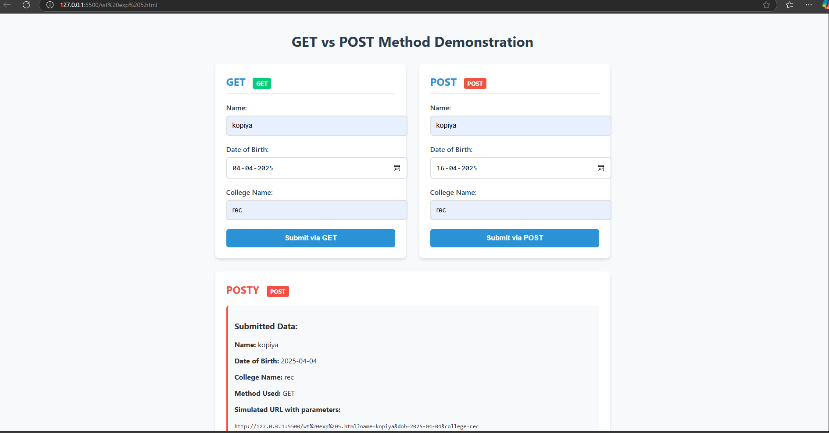

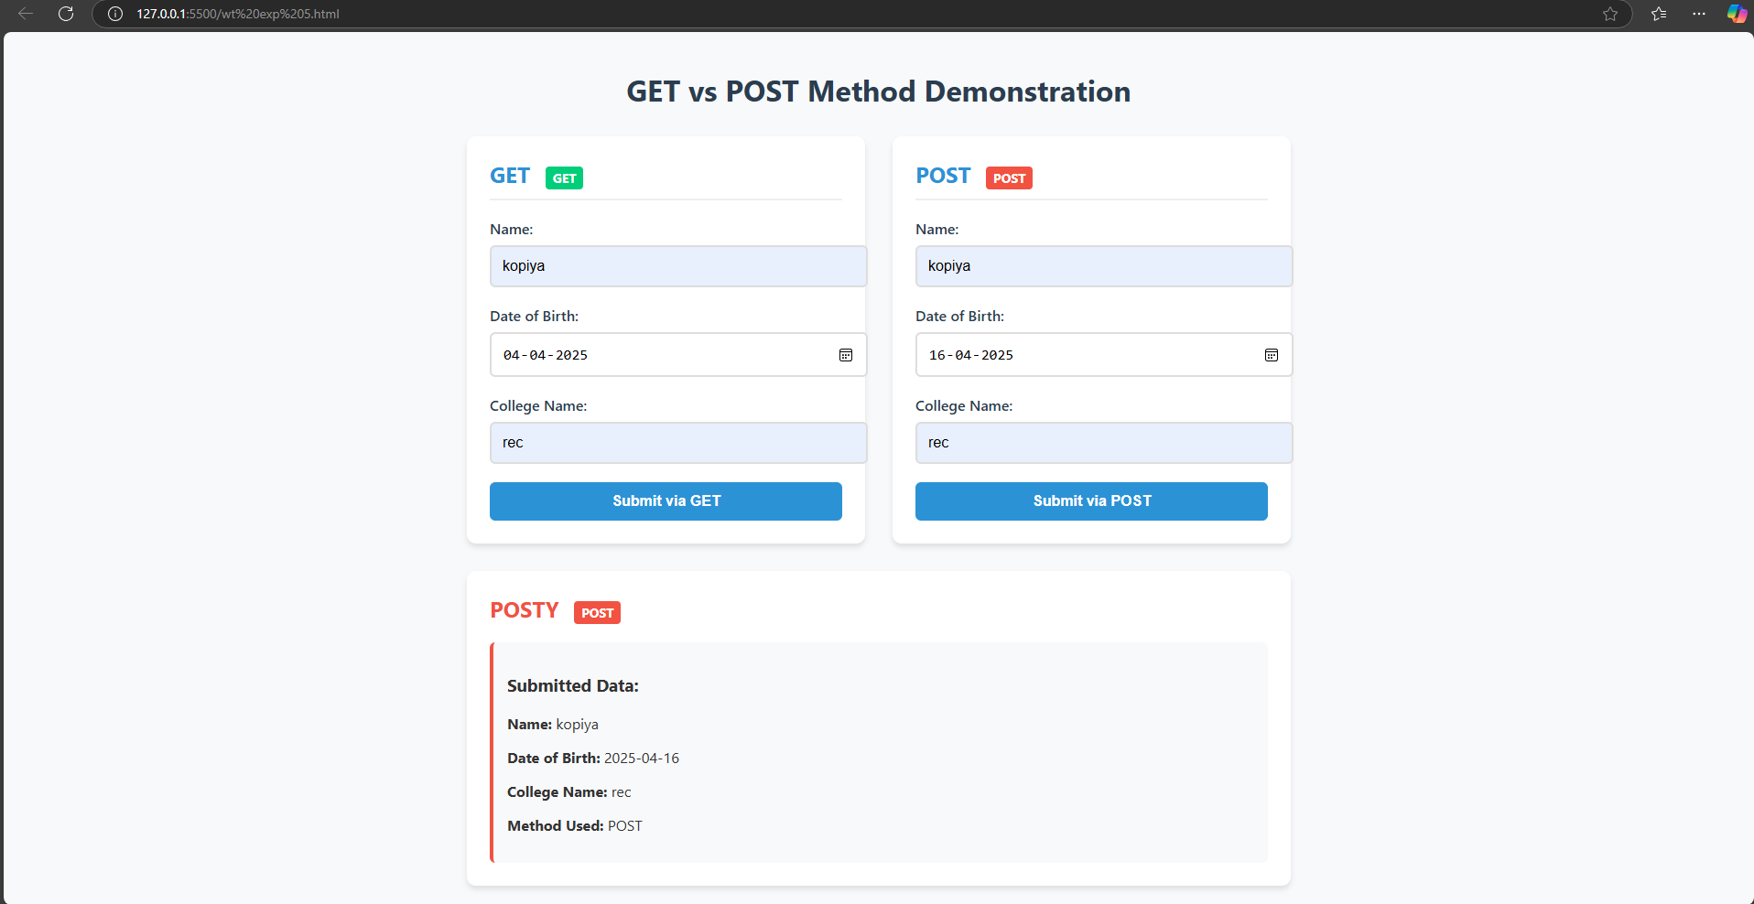

**RESULT:** The Get and Post methods were executed successfully.